EX.No:6
DATE:
USE CASE DIAGRAM FOR ATM WITHDRAWAL SYSTEM

Aim:

To design and analyze a Use Case Diagram for the Library Management System using UML concepts.
.Problem Statement:

To model the interaction between the library members and the librarian with the Library Management System during book search, issue, return, and fine management processes, and to-represent-the-communication-between-the-system-and-the-database
System Description:
The Library Management System allows members (students/staff) to search, issue, return, and renew books. The member logs into the system, searches for a book, checks availability, and requests to issue the book. The system verifies availability in the database before issuing the book. When returning a book, the system checks for due date and calculates fine if applicable. If a fine is generated, the member pays the fine. The librarian manages book records by adding, removing, and updating book details.
All transactions and records are stored in the database.

Relationships:
- Check Availability
- Update Book Record
- Calculate Fine
- Update Book Record
- Check Availability:
- Calculate Fine
Use-case diagram:

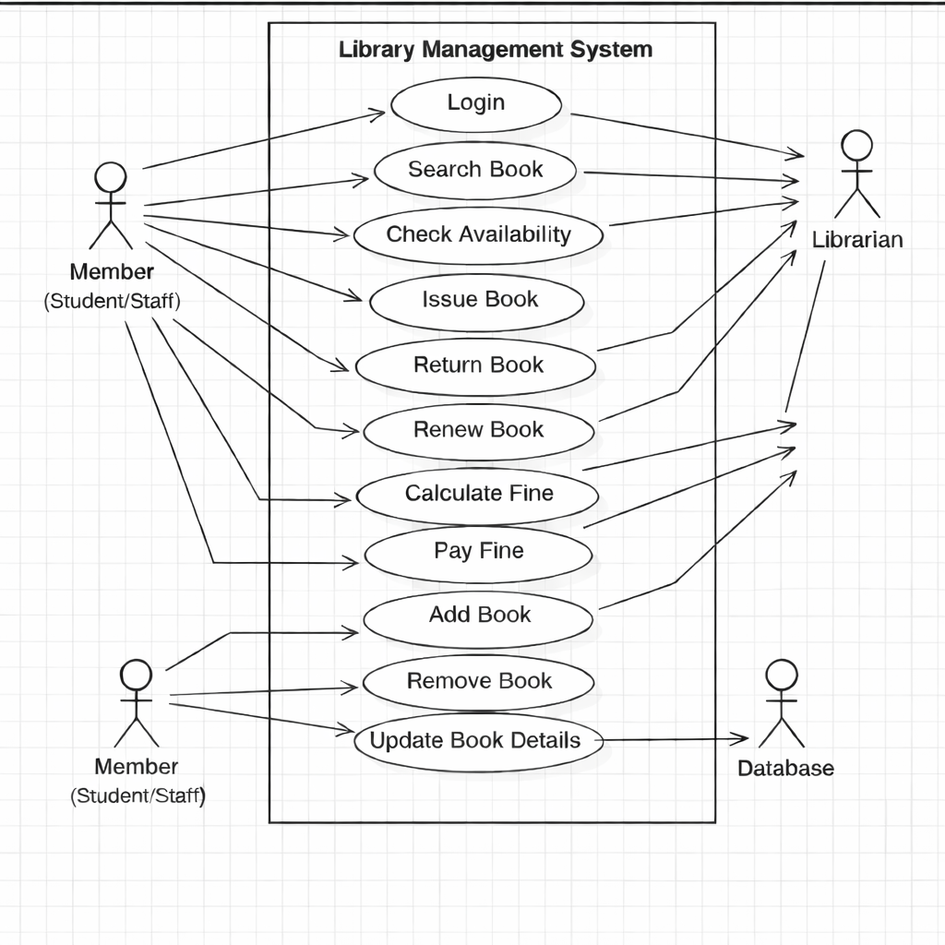

Actors Identified:
- Member (Student/Staff) – Searches, issues, returns, and renews books.
- Librarian – Manages book records and generates reports.
- Database – Stores book details, member records, and transaction information.

System Boundary:

The system boundary is represented as “Library Management System”, which contains all the use cases involved in book management and transactions .Use Cases Identified:
- Login
- Search Book
- Check Availability
- Issue Book
- Return Book
- Renew Book
- Calculate Fine
- Pay Fine
- Add Book
- Remove Book
- Update Book Details
- Generate Reports

Result:
Thus, the Use Case Diagram for Library Management System was successfully designed using UML notation.

